Selecting Region Codes in ESS and Creating a Personalized Region Code List
Beginning December 11, 2011, the country code and region code selections have separate drop down boxes.

The country code will always default to USA.
There are two different ways to select a region code.
1.) From the Generic SAP-Provided List, or
2.) From a Personalized List (Click here to setup a custom Personalized List)

Option 1 - Selecting a Region Code from the Generic SAP-Provided List
If staying in a high cost area, use the drop down menu to search for the correct region code.
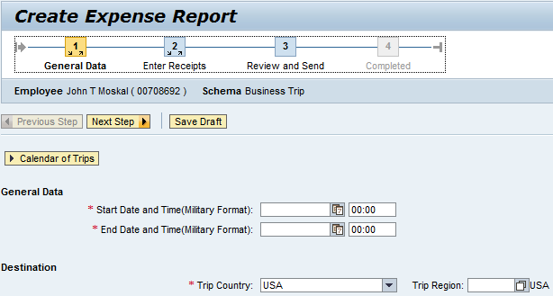
Select “Show Search Criteria.”
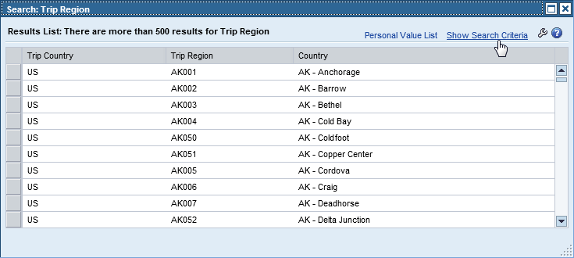
To the right of the Country/Group/Region field, select from the drop down menu ‘contains’, in the next field to the right enter the 2-digit postal state abbreviation, then select “Search.”
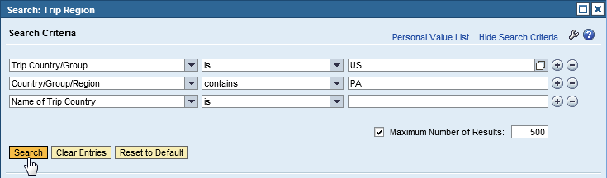
This list of available region codes is returned.
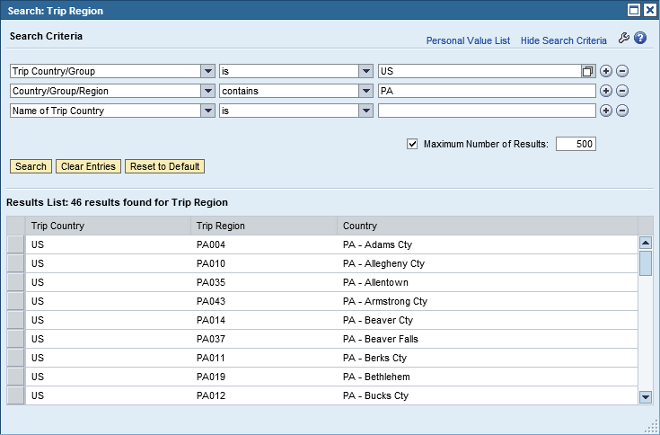
Select the region code.

Option 2 - You can change the field ‘Maximum Number of Results’ to 5000 to list every State and region code.
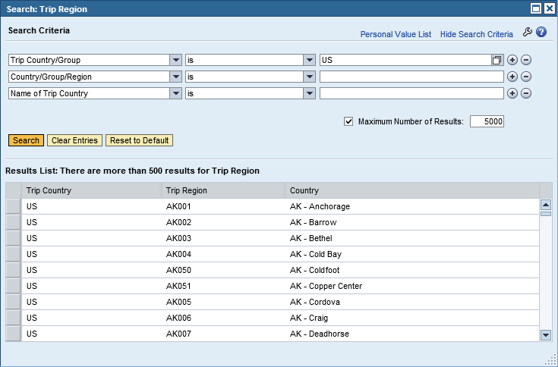

Option 3 - Selecting a Region Code from the Personal Value List
If staying in a high cost area, use the drop down menu to search for the correct region code. Select “Personal Value List.”
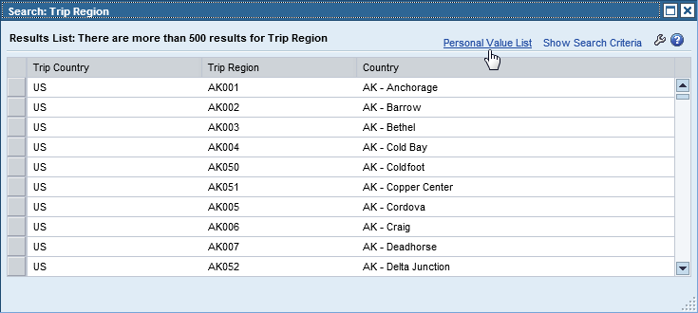
Select the region code.

Need to Setup a Personalized Value List?
Follow these steps to create your own customized list.
Use the drop down menu to search for the correct region code.

Select “Personal Value List.”
Your customized list of personal region codes will appear.
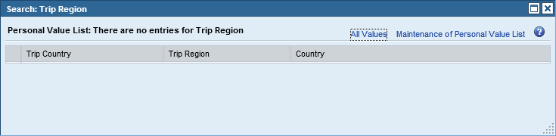
If there are no region codes or you need to maintain (add/delete) region codes, select “Maintenance of Personal Value List.”
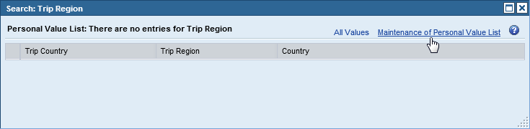
Two lists will appear. The list on the left side will display region codes available for selection. To narrow down the search results, use the search functionality. The list on the right side will display your personalized list of region codes.
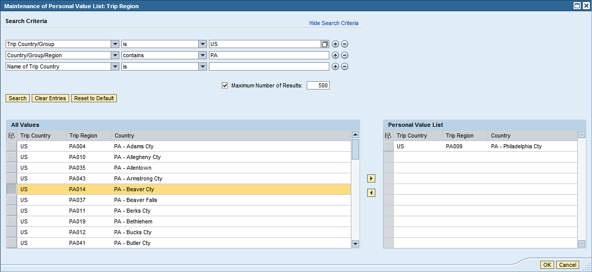

To ADD a region code, select the region code on the left side and then select the Add item arrow.
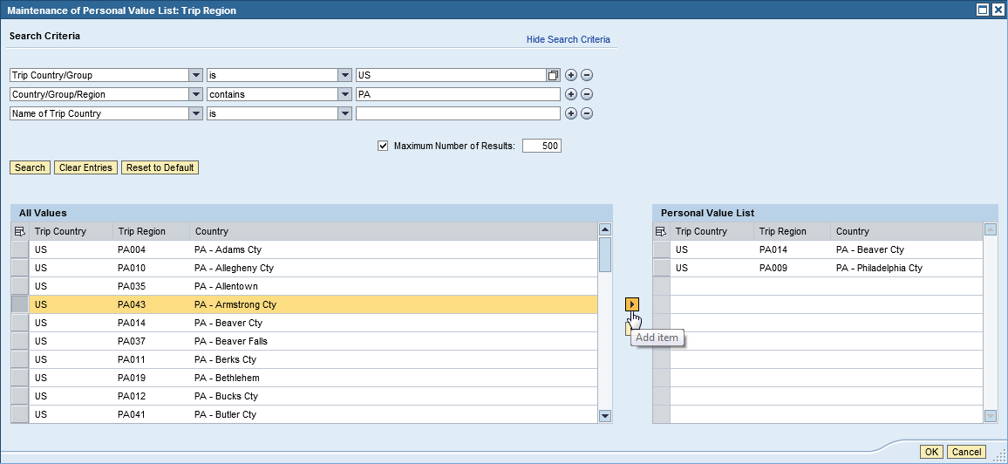
To DELETE a region code, select the region code on the right side and then select the Remove item arrow.
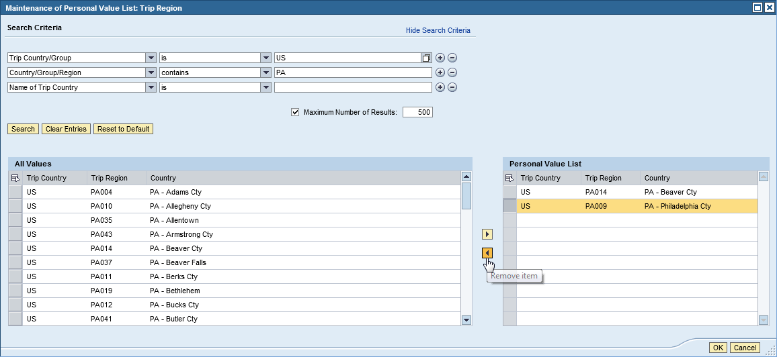

When you have completed making changes to your personalized list of region codes, select “OK” to save the list. Your personalized list of region codes will appear.
